Task 2: Ethernet frame inspection
1. filter eth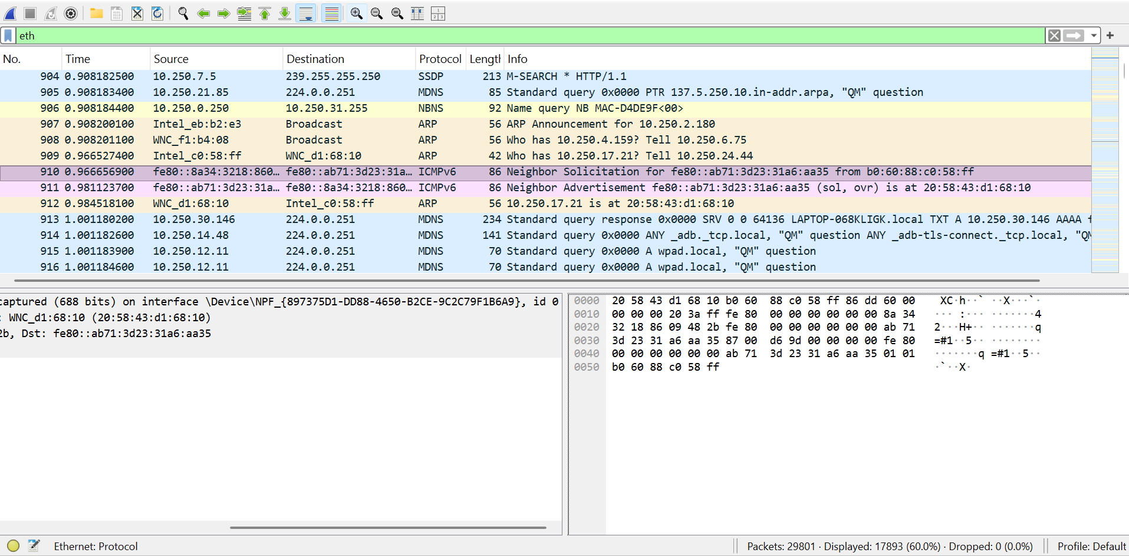
2. five different packets
Packet 1
Frame number & frame length
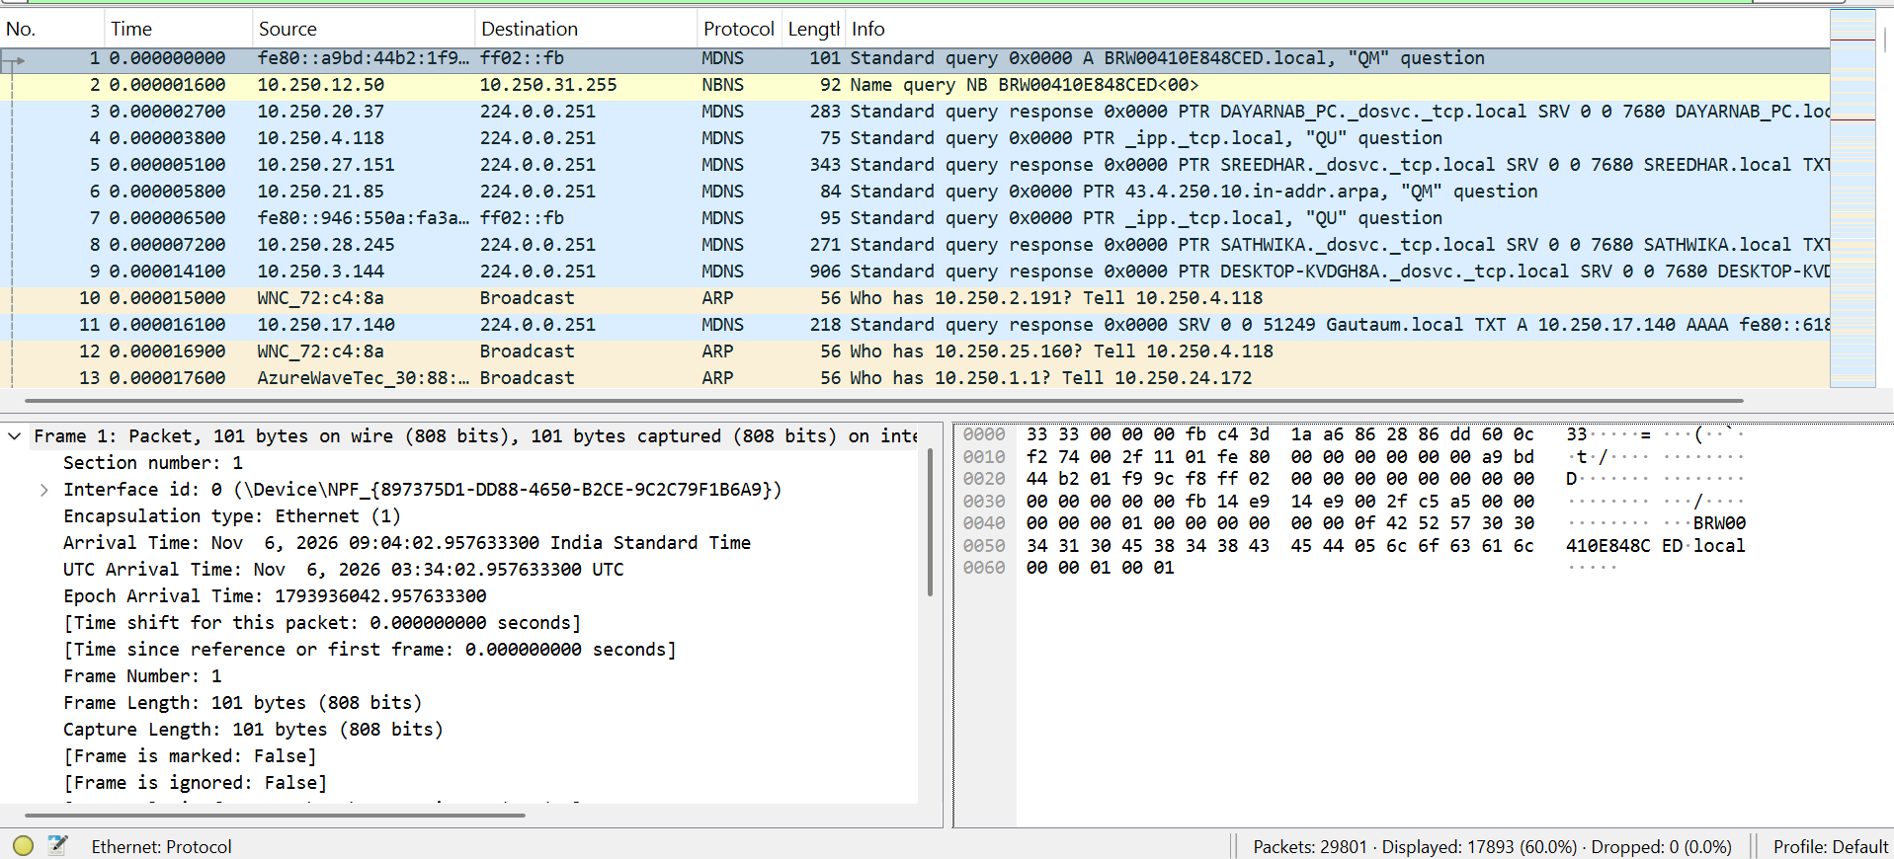
Ether Type, Source & destination address
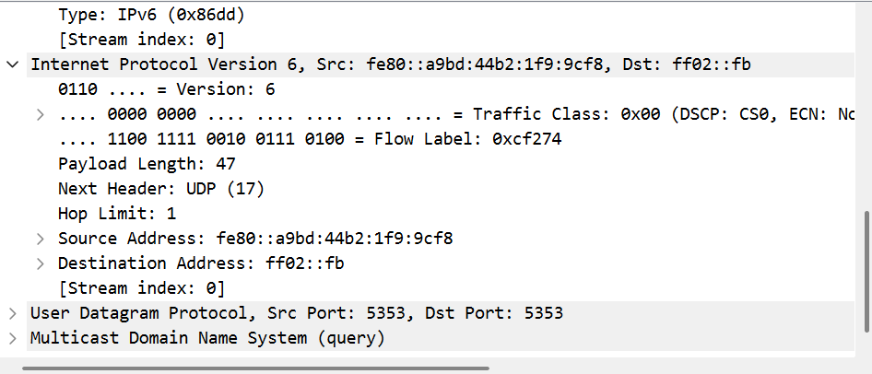
Packet 2
Frame number & length
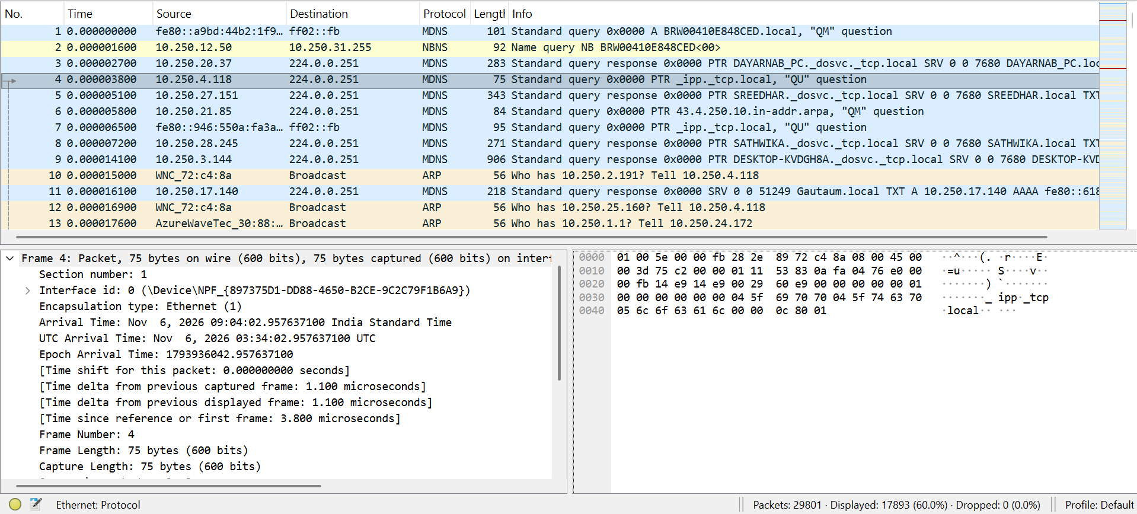

Ether Type
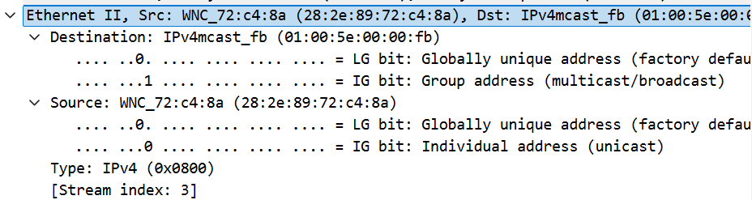

Source & destination address
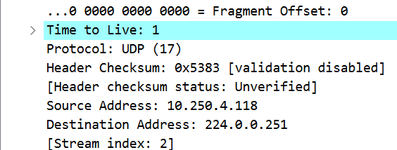

Packet 3
Frame number & length
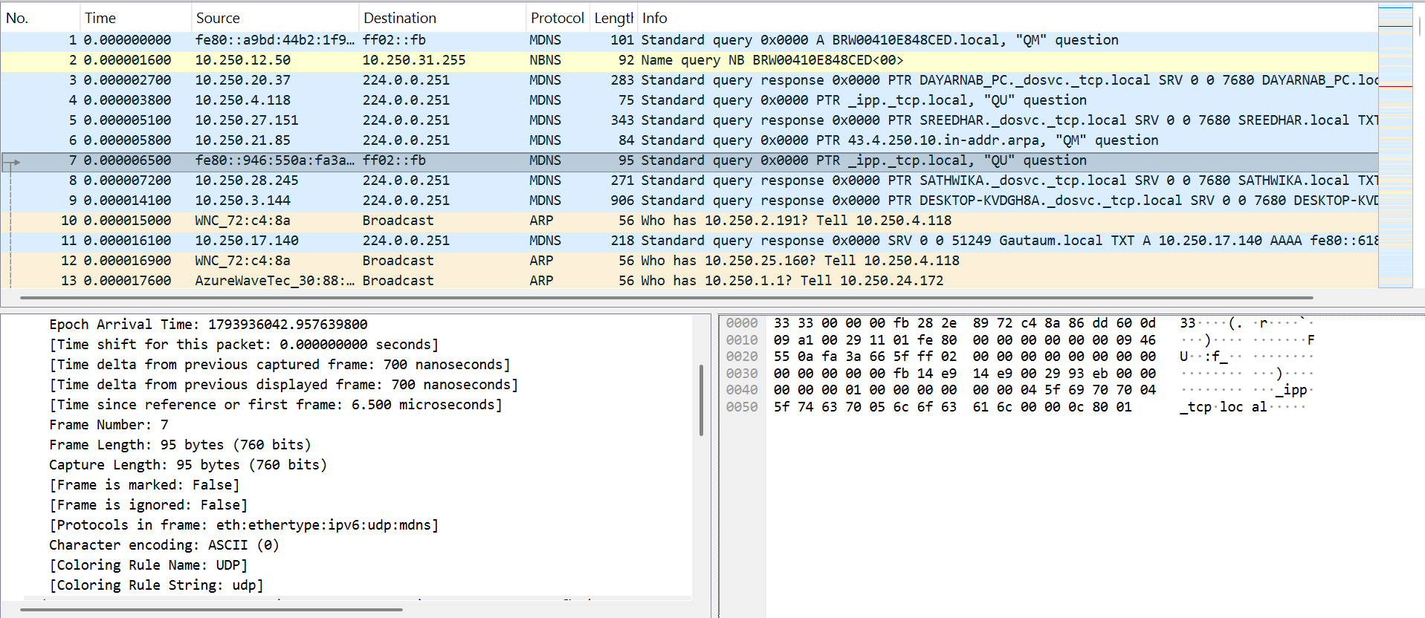

Ether Type
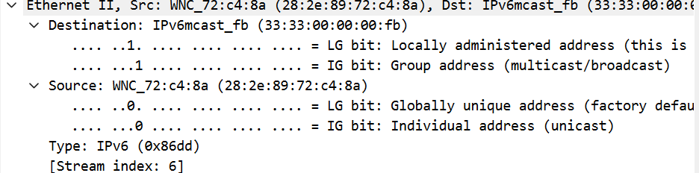

Source & destination Address
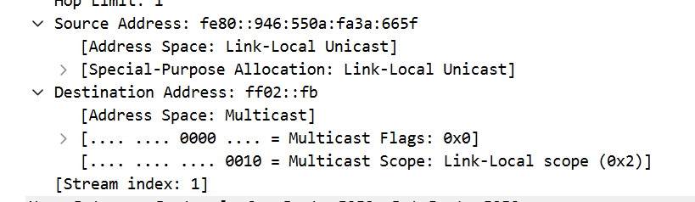
Packet 4
Frame number & length
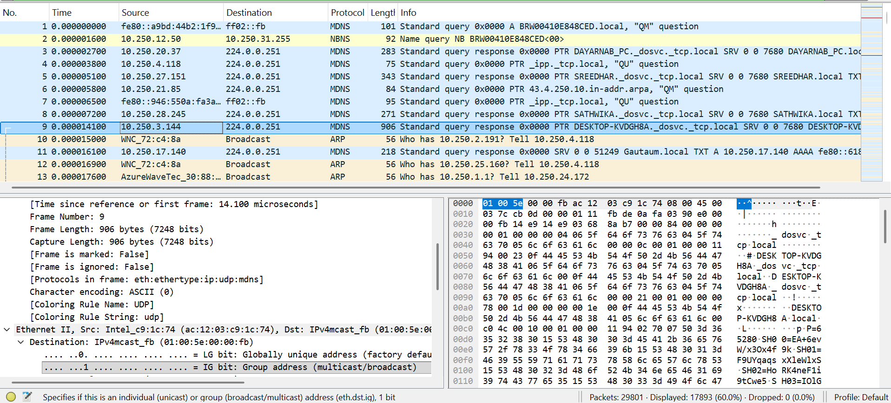

Ether Type
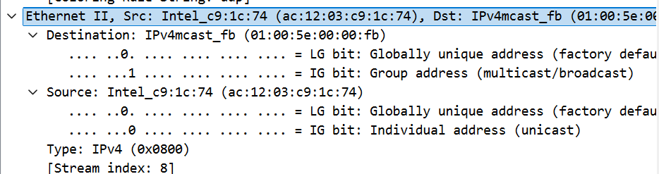

Source & destination Address
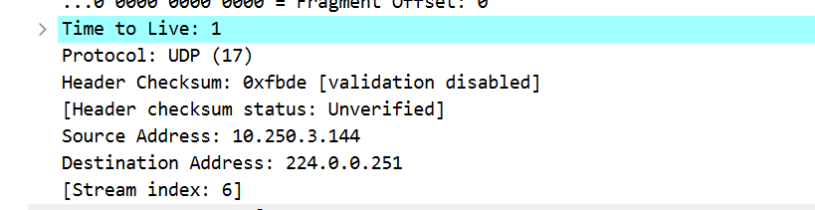

Packet 5
Frame number & length
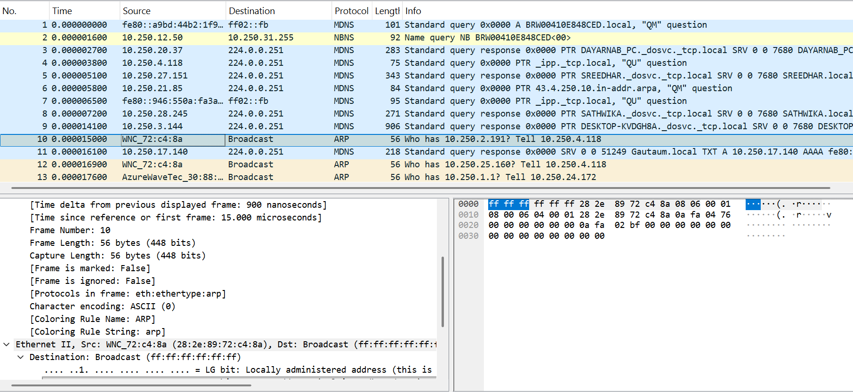
Ether Type
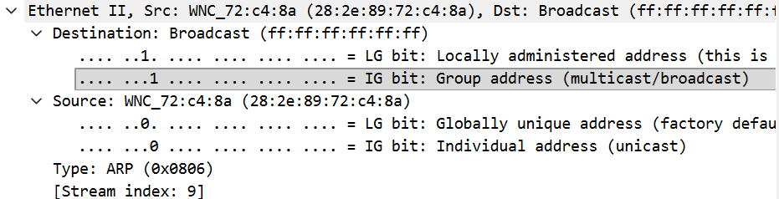

Source & destination Address
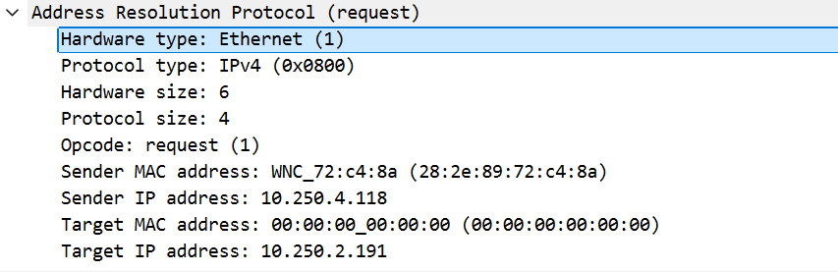

3. packets carrying IPv4 and IPv6 traffic
IPv4
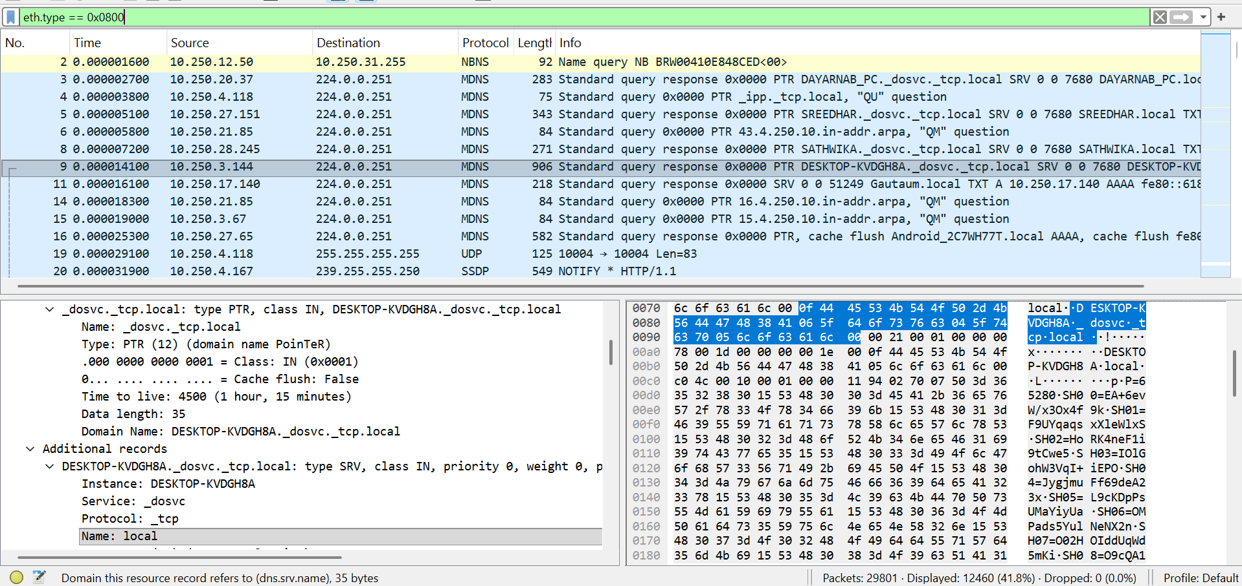
IPv6


